Homework



Answer the questions by SQL.

1. **List all the employees whose salaries are more than 3000.**

SELECT * FROM EMP WHERE SAL > 3000;



1. **List all the employees whose names begin with “S”.**

SELECT * FROM EMP WHERE ENAME LIKE 'S%';

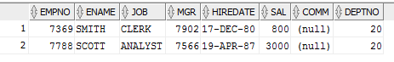

1. **List the employees whose name is “SMITH”, “ALLEN” or “FORD”.**

SELECT * FROM EMP WHERE ENAME IN ('SMITH', 'ALLEN', 'FORD');

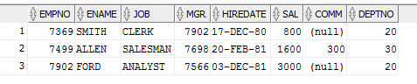

1. **List all the employees whose department is “SALES”.**

SELECT E.* FROM EMP E JOIN DEPT D

ON E.DEPTNO = D.DEPTNO

WHERE D.DNAME = 'SALES';

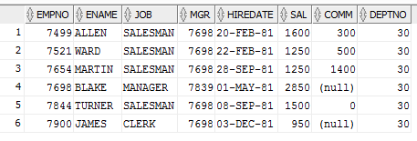

1. **To get the value of average, biggest, smallest and total of each department, and order by department number.**

SELECT D.DEPTNO, AVG(E.SAL) AS "AVERAGE SALARY",

MAX(E.SAL) AS "MAX SALARY",

MIN(E.SAL) AS "SMALLEST SALARY",

SUM(E.SAL) AS "TOTAL SALARY"

FROM DEPT D

JOIN EMP E

ON D.DEPTNO = E.DEPTNO

GROUP BY D.DEPTNO

ORDER BY D.DEPTNO;

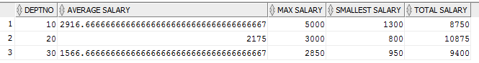

1. **To get the total number of employees, whose salary is more than 3000 for each department.**

SELECT D.DNAME, COUNT(E.EMPNO) FROM DEPT D

JOIN EMP E

ON D.DEPTNO = E.DEPTNO

WHERE E.SAL > 3000

GROUP BY D.DNAME;



1. **TO get the number of the average salary for each department, according to the department name in ascending order**

SELECT D.DNAME, AVG(E.SAL) FROM DEPT D

JOIN EMP E

ON D.DEPTNO = E.DEPTNO

GROUP BY D.DNAME

ORDER BY D.DNAME;

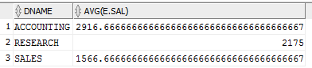

1. **List the statistics of employees who have the same salary in each department, list their department number, salary, and number of employees.**

SELECT D.DEPTNO, E.SAL, COUNT(E.EMPNO) AS COUNTEMP

FROM DEPT D JOIN EMP E

ON D.DEPTNO = E.DEPTNO

JOIN EMP E2

ON E.EMPNO = E2.EMPNO

WHERE E.SAL = E2.SAL

GROUP BY D.DEPTNO,E.SAL

HAVING COUNT(E.EMPNO) > 1;

-- OTHER WAY FOR NUMBER 8

SELECT E1.DEPTNO, E1.SAL, COUNT(E1.EMPNO)

FROM EMP E1 JOIN EMP E2

ON E1.EMPNO = E2.EMPNO

WHERE E1.SAL = E2.SAL

AND E1.DEPTNO = E2.DEPTNO

GROUP BY E1.DEPTNO, E1.SAL

HAVING COUNT(E1.EMPNO) > 1;

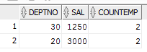

1. **List the number of department with more than 2 employees in the same department, showing the name of the Department, the name of the area, and the number of the employees in the same department**

SELECT D.DNAME, D.LOC, COUNT(E.EMPNO) FROM DEPT D

JOIN EMP E ON

D.DEPTNO = E.DEPTNO

GROUP BY D.DNAME, D.LOC

HAVING COUNT(E.EMPNO) > 2;

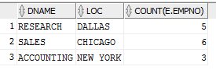

1. **List the name and salary of employees whose salaries is higher than the average salary of the entire firm**

SELECT ENAME, SAL FROM EMP

WHERE SAL > (SELECT AVG(SAL) FROM EMP);

